**EXPRESSION: (a+b)\*(c+d)/(b+d)**

.model small

.data

a dw 245h

b dw 25h

c dw 34h

d dw 50h

r1 dw ?

quo dw ?

rem dw ?

.code

mov ax,@data

mov ds,ax

mov ax,a

add ax,b

mov r1,ax

mov ax,c

add ax,d

mul r1

mov bx,b

add bx,d

div bx

mov quo,ax

mov rem,dx

mov ah,4ch

int 21h

end

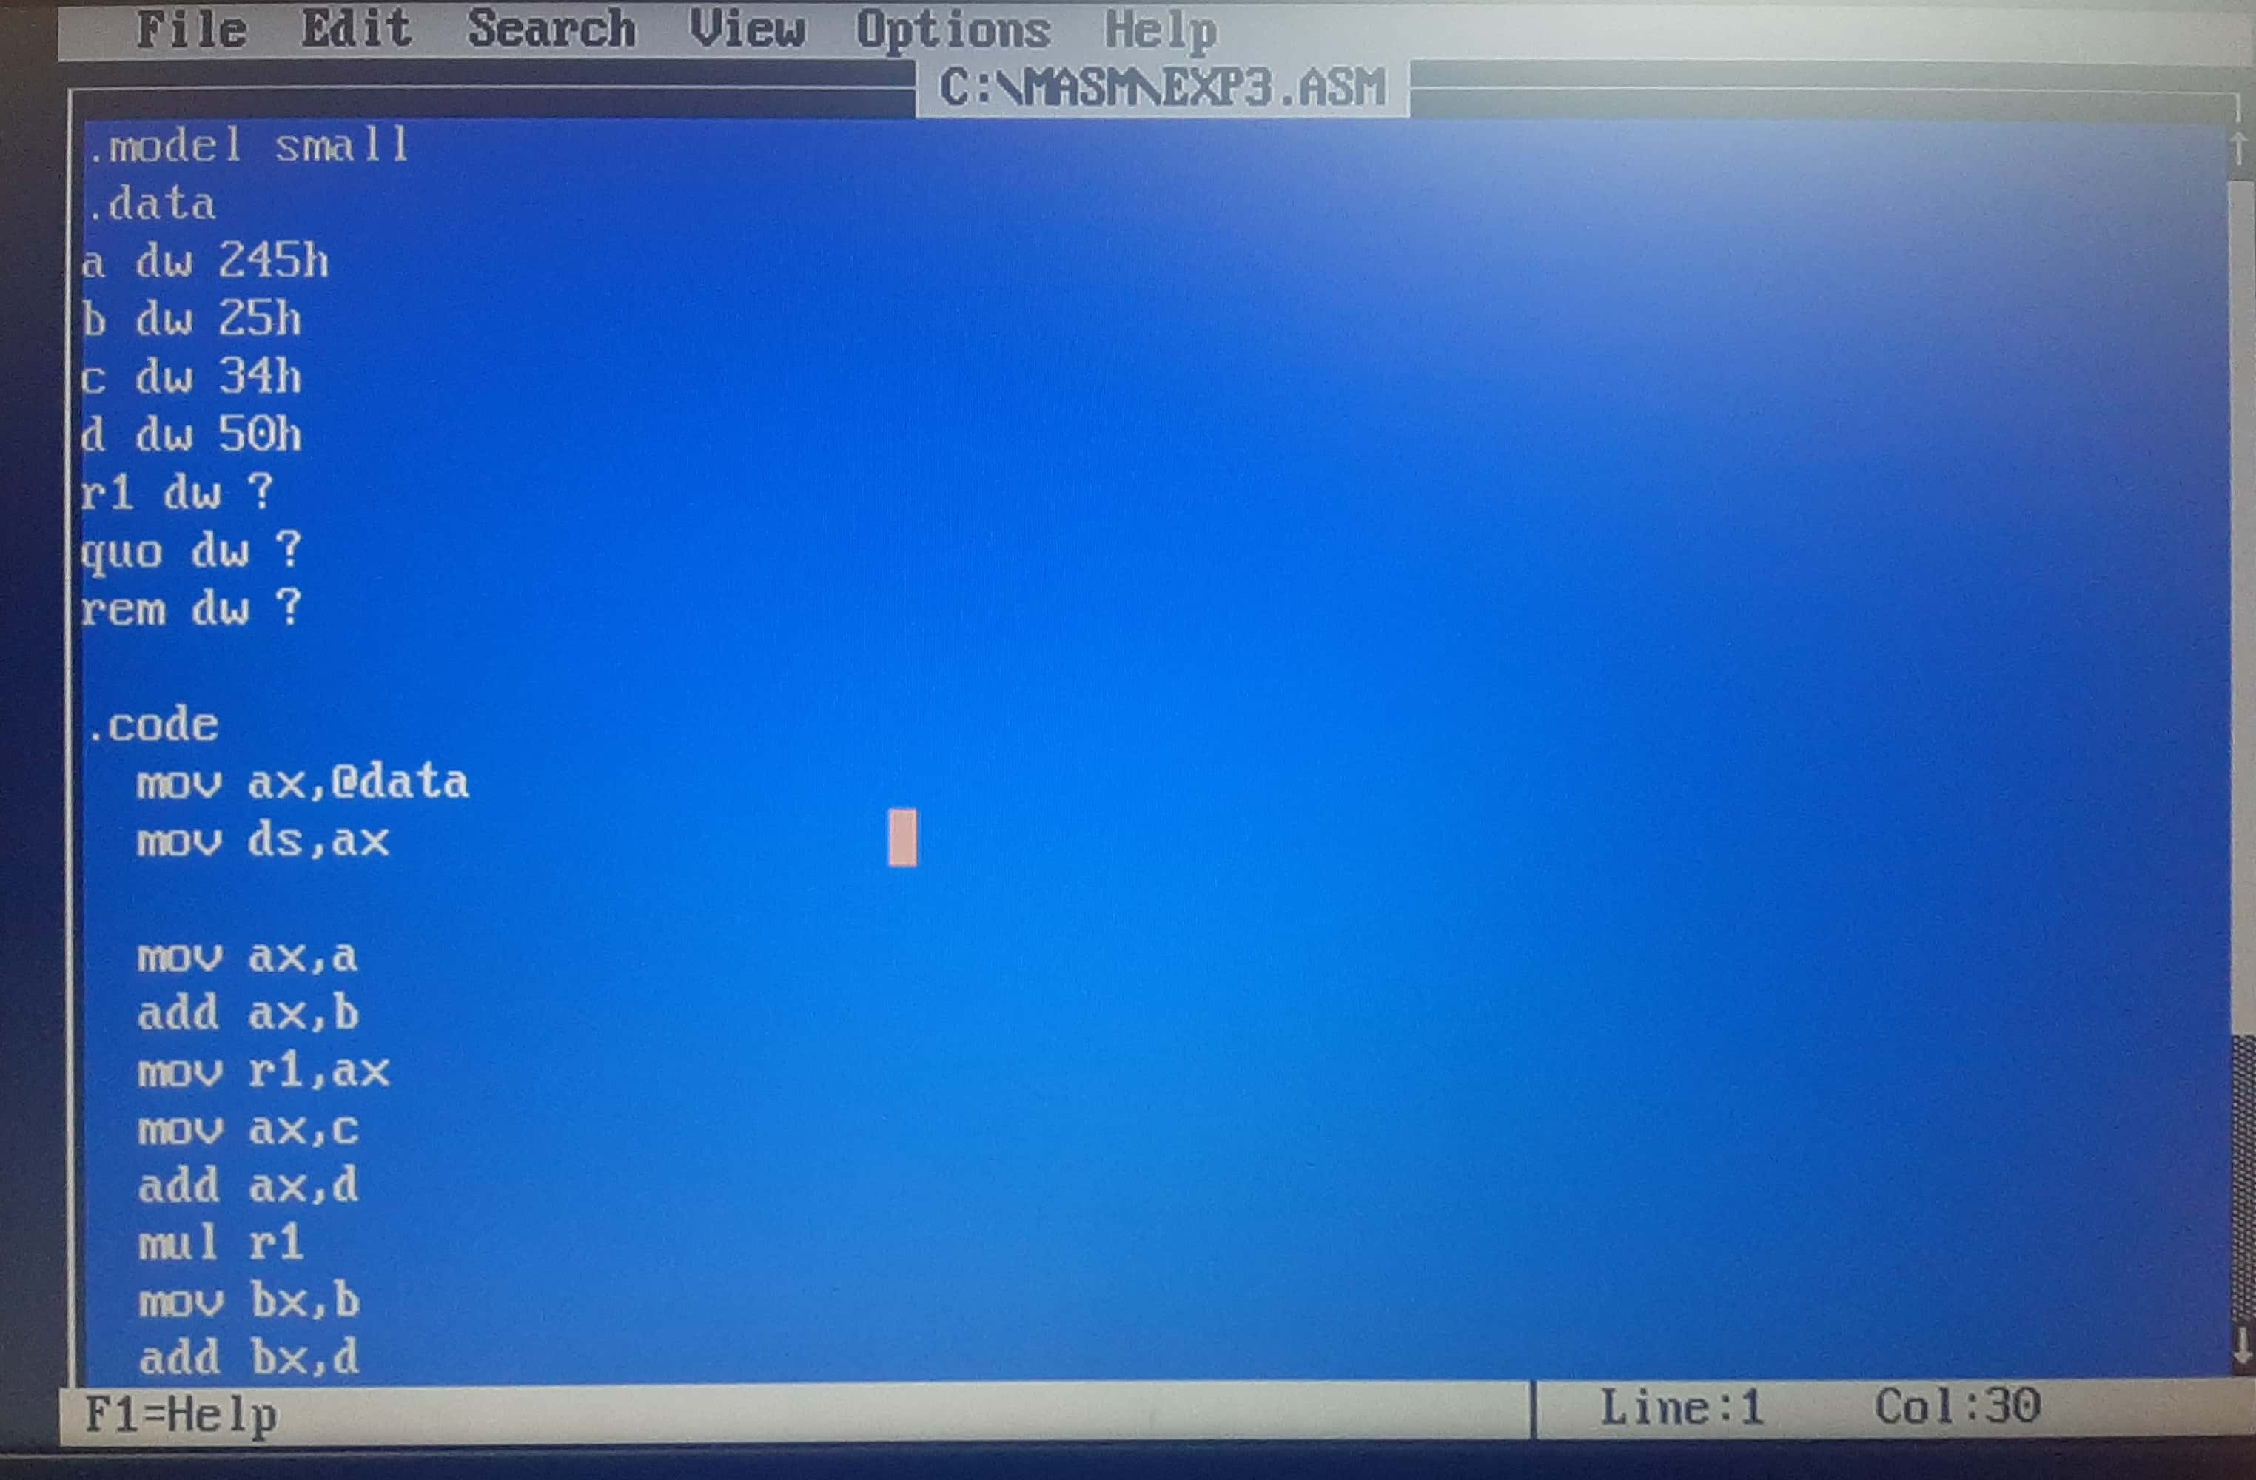

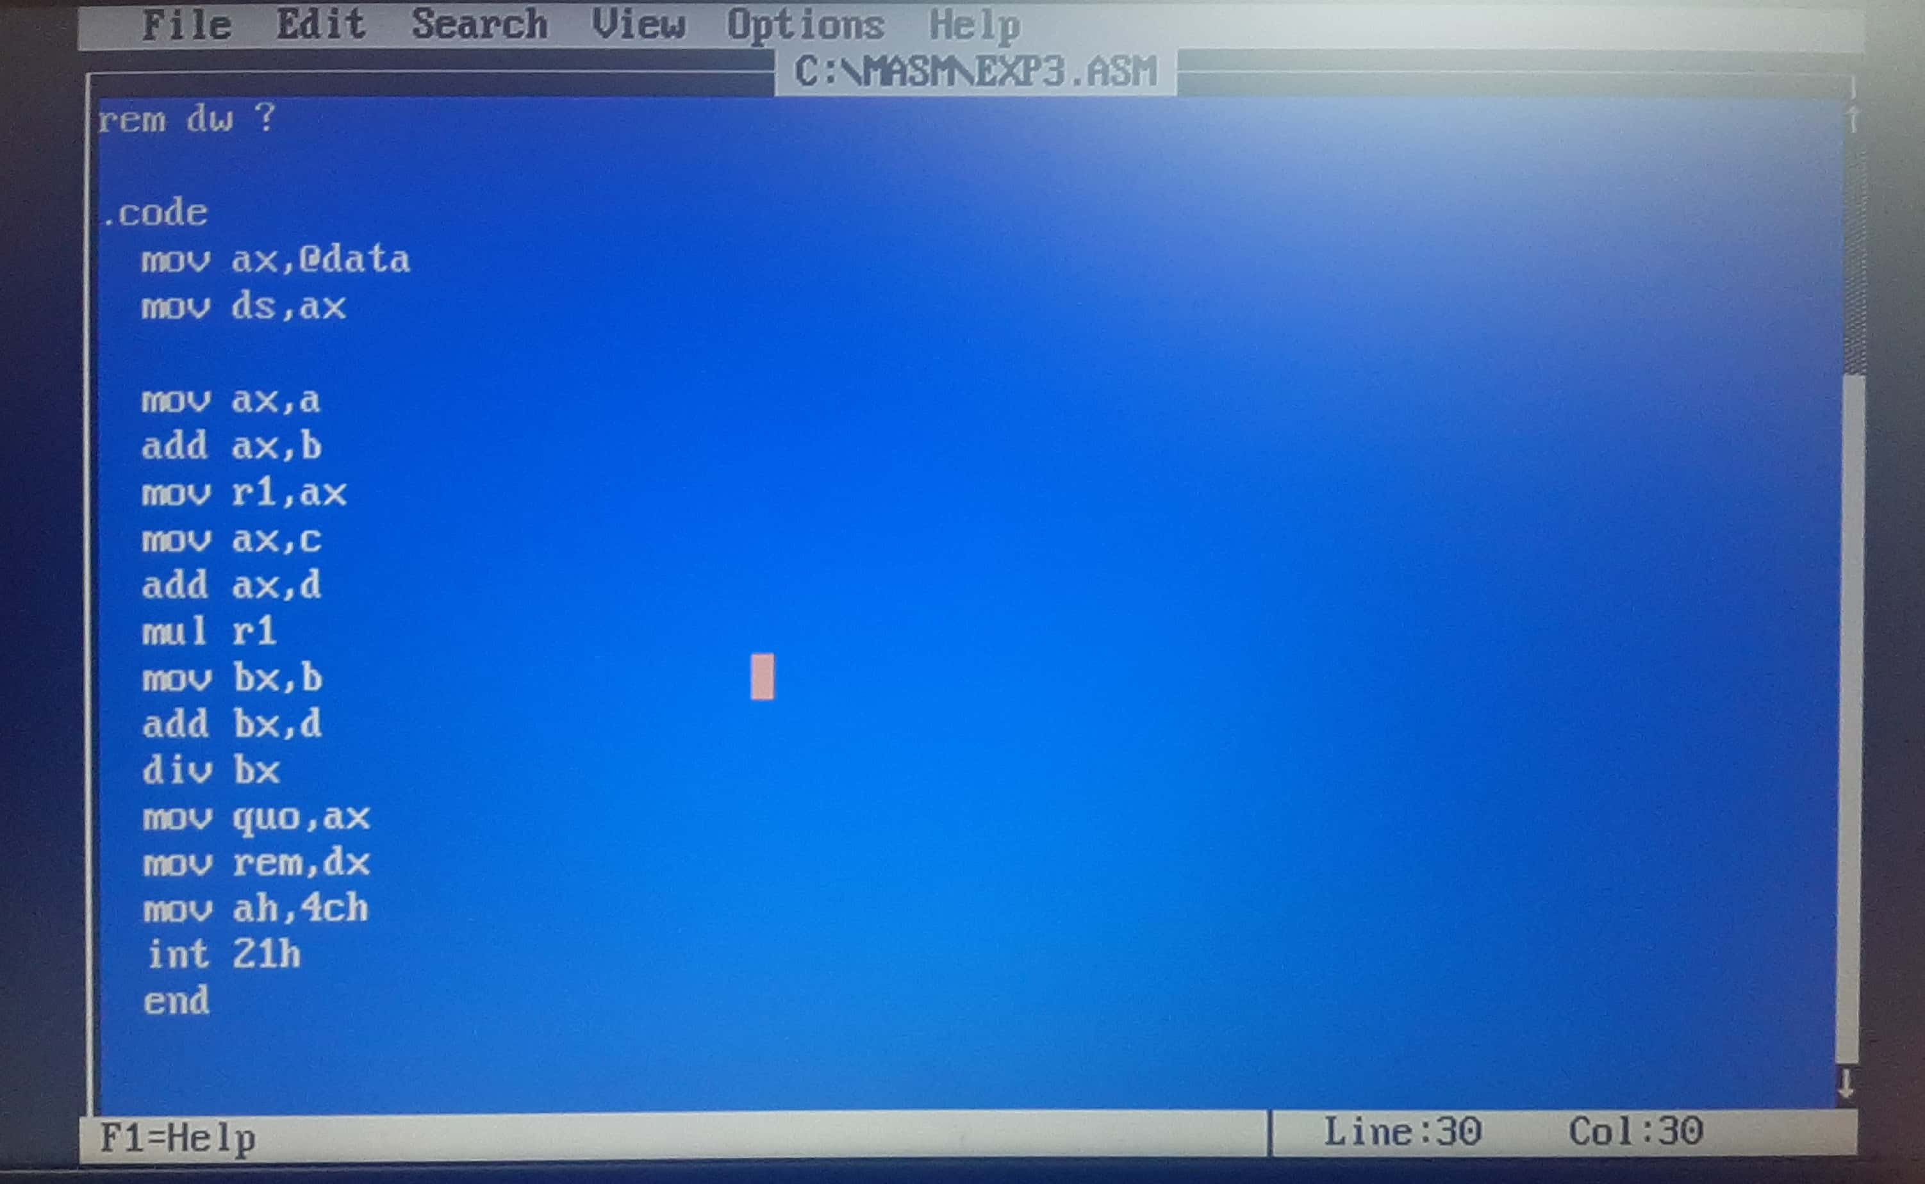

OUTPUT:

